Analysis of Residues from AESUB Blue 3D Scanning Spray
Emily Brzezinski and Lauren Horelick, National Museum of Air and Space (NASM)
October 26, 2020

BACKGROUND

AESUB Blue State of the Art ScanningSpray is produced in Germany and distributed by 3D Capture in the United States. It is sprayed on the surface of an object before 3D scanning, making it easier to capture transparent, reflective, dark, or otherwise difficult to scan surfaces. The spray is intended to fully sublimate within four hours of application, leaving no residues and requiring no cleaning.

The conservation department at NASM is considering utilizing AESUB Blue for scanning objects in their collection. However, its use on museum objects requires further study, as these materials often have historic, unique, or degraded surfaces that could be damaged by any residues or added substances. Specifically, NASM has a collection of cellulose acetate aircraft recognition models that may require scanning in the near future. The models’ matte black surfaces could make capturing details difficult, necessitating a coating of AESUB Blue Scanning Spray. The surface of the recognition models is porous and degraded, and any residues risk long term damage to the plastic.

This study was an initial step in assessing the suitability of AESUB Blue for use on museum objects, with a focus on the cellulose acetate of the aircraft recognition models. Fourier transform infrared spectroscopy (FTIR) and imaging with a Hirox Digital Microscope gave an initial picture of how effectively the material sublimated.

Sampled Material

Samples were chosen from the NASM study collection. These materials were chosen with the aircraft recognition model project in mind, and therefore included several plastics and a sample from a deaccessioned recognition model. This spray is commonly used on reflective or transparent materials, so a glass and aluminum sample were also included. Additionally, the glass and aluminum tested the spray’s behavior on other materials frequently encountered at NASM and provided a non-polymeric sample that could serve as a baseline for FTIR results.

Sample Number | Object | Material
1 | Time Scale, plastic | Polyvinyl chloride/polyvinyl acetate copolymer
2 | Index Chart, plastic | Polyvinyl chloride/polyvinyl acetate copolymer
3 | Glass laboratory slide | Silicon glass with acetal coating
4 | Aircraft recognition model fragment (deaccessioned) | Cellulose acetate with DEP and TPP additives
5 | Aluminum laboratory tin, no coating | Aluminum
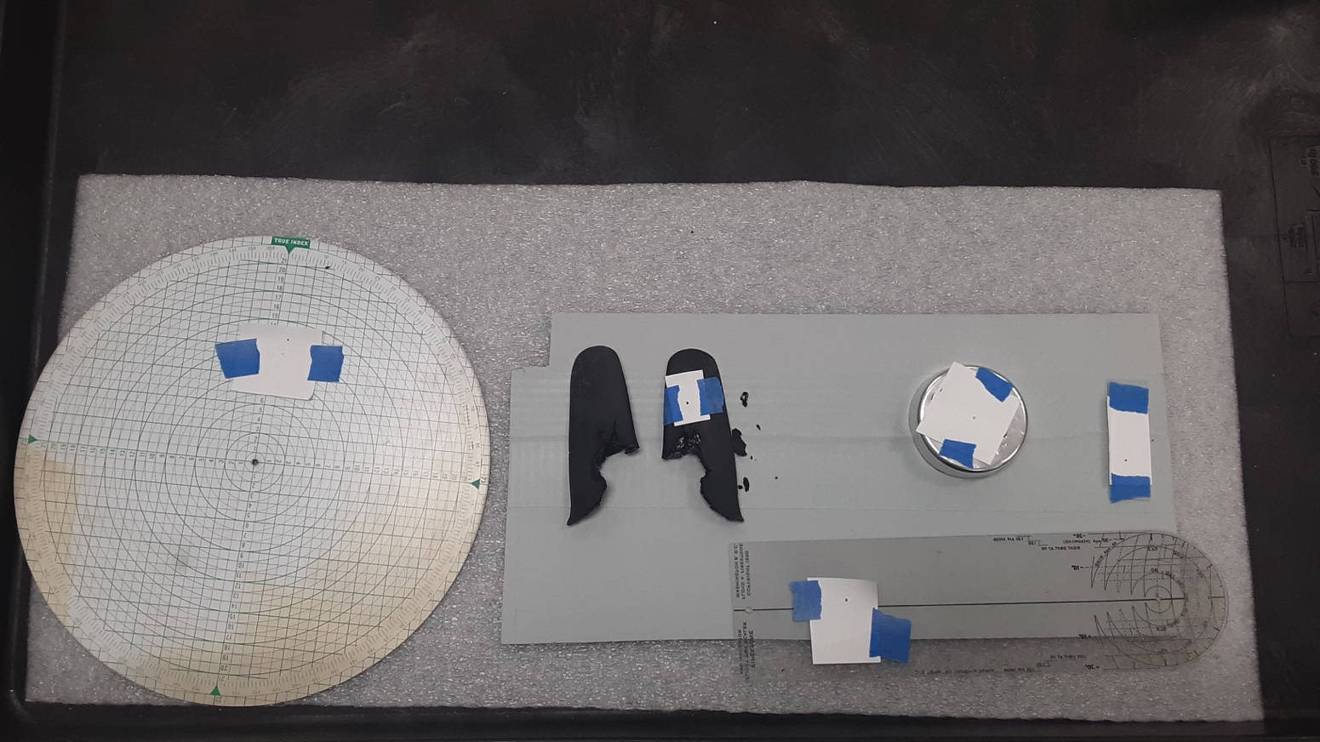
2
3
5
4
1cvcv. Material identification relied heavily on NASM’s reference library which is non-exhaustive.

Fig. 1. Sample materials from the NASM study collection with paper “windows” in place.
Sample 1 – time scale, 4 – recognition model fragments, 5 – aluminum pan, 3 – glass slide, 2 – index chart

PROCEDURE

- Samples of various materials were selected from the NASM study collection.

- The surface of the sample material was surface cleaned with deionized water or isopropanol, depending on the material, to remove surface dirt and grime.

- The samples were scanned using FTIR and imaged with a Hirox Digital Microscope.
- Paper “windows” were placed over the surface to ensure the same section was imaged with the Hirox before and after application.

- Leaving the paper “windows” in place, the samples were sprayed with AESUB Blue.

- Sample 1 and 4 were scanned using FTIR with the AESUB spray on the surface. All samples were imaged with Hirox.

- The samples were allowed to sublimate for the required 4 hours.

- The samples were scanned using FTIR and imaged with Hirox after four hours, when the AESUB Blue should have fully sublimated.

RESULTS

Hirox Digital Microscope Images

It appeared that the AESUB Blue fully sublimated from all sample materials within the expected four hours. No residues were seen in the sample area with the Hirox, although light specs were visible on the glass slide (Sample 3). However, AESUB Blue residues were still visible on the wingtip of the cellulose acetate aircraft recognition model samples, as well as on the blue tape used to adhere the paper to the surface on the other samples. These areas were examined with the Hirox after the four-hour sublimation time (figure 2, below), and white residue from the AESUB Blue is visible in the interstices of the plastic.

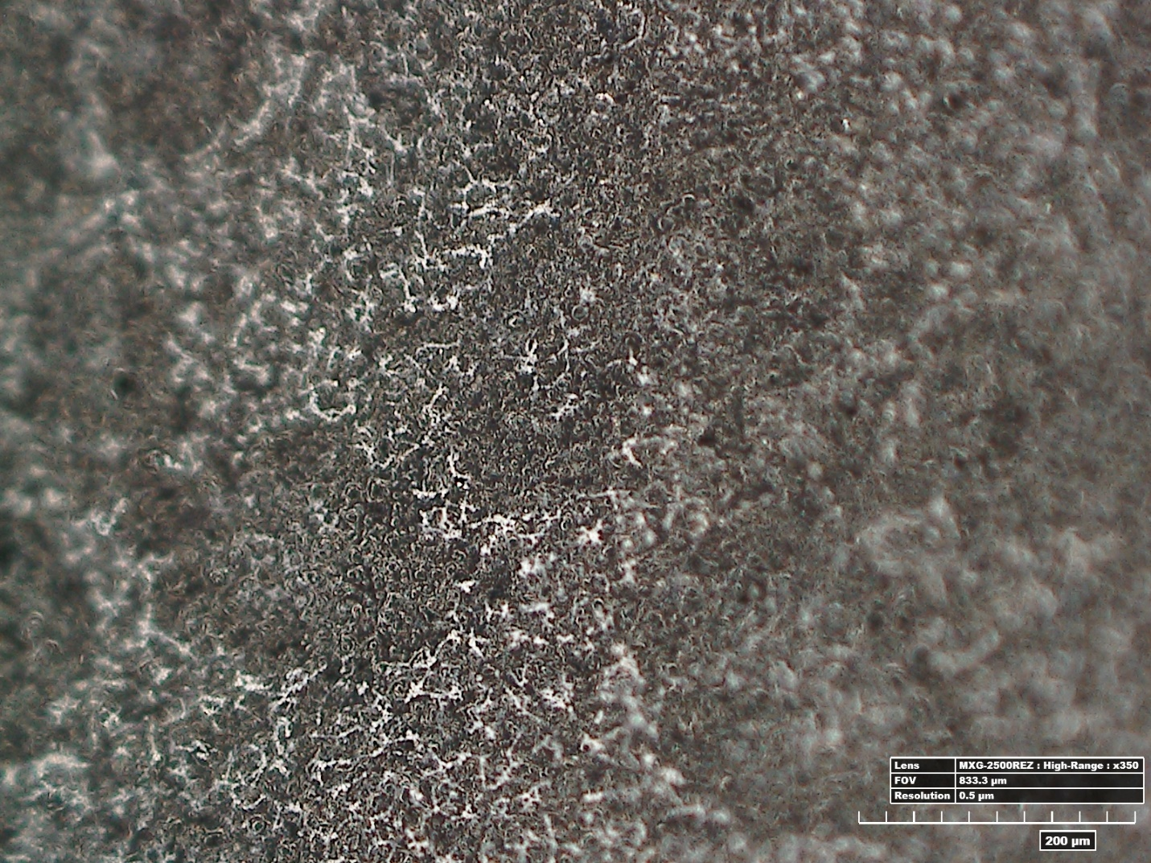
Fig. 2: Hirox image of the wingtip of the aircraft recognition model fragment (Sample 4). This residue was not observed in the sampled areas but had not disappeared by the four-hour mark.

Fourier Transform Infrared Spectroscopy

The FTIR results were somewhat inconsistent. The method gave an excellent spectrum of the AESUB Blue ScanningSpray and identified the material as primarily low-density polyethylene (LDPE), possible containing zinc oxide (see Table 1 and figure 4, following pages).

However, the three dimensionality and fragility of the samples (such as Sample 4, the recognition model fragment) did not allow for good contact with the sensor without risk to the sample. The FTIR spectra for the sample material did not always match the same library entry before and after spray application, much less correctly identify the sample material. However, no clear indication of residues was present after the spray had sublimated.

DISCUSSION

The application method of the spray may affect the sublimation and subsequent reside. The residue seen on the wing of the aircraft recognition model may due to thicker application or areas where the spray pooled which could take longer than four hours to sublimate. These areas were visually examined one week after the spray was applied, and the white tidelines were still evident, although the residues could be reduced with a Kimtech wipe. This may indicate that thicker application of AESUB Blue does not fully sublimate from porous surfaces.

NASM’s FTIR spectra library is non-exhaustive. Given the difficulties accessing the sensor, we did not expect this method to perfectly identify each sample material to a high degree of accuracy. However, we hoped for consistent material ID before application and after spray sublimation, or to see clear remnants of the spray material after sublimation. While we did not see any LDPE after sublimation, the material identification was also inconsistent.

CONCLUSION

This preliminary study suggests that AESUB Blue ScanningSpray may not be safe for degraded or porous surfaces, such as those on the cellulose acetate aircraft recognition models. This is primarily based on the tidelines observed near the testing area which did not sublimate after one week on the surface. However, the AESUB Blue spray seemed to successfully sublimate from all other sampled materials with no change to the surface, although the glass slide (Sample 3) exhibited specks in the Hirox. This suggests that the tidelines may be from incorrect application of the spray. Even if the AESUB Blue spray leaves minimal residues, it may be possible to remove them after scanning with a gently brush or deionized water. The efficacy of these methods should be examined if 3D scanning necessitates the use of AESUB Blue on the models.

Since sublimation is not guaranteed and there appears to be variation in the way AESUB Blue interacts with different materials and surfaces. Therefore, NASM conservation labs should reexamine the effects of AESUB Blue Spray on a case by case basis.

FTIR DATA

Table 1: Material Identification Provided by Fourier Transport Infrared Spectroscopy

Sample | Identification of Sample  Before Spray Application (BT) | Identification  Spray Applied (DT) | Identification of Sample  After Sublimation (AT)
1 – PVC/PVA  time scale | 90% Vinyl chloride/10%vinyl acetate copolymer | “Moisture-resistant LDPE polyethene rod” | 90% Vinyl chloride/10%vinyl acetate copolymer
2 – PVC/PVA  index chart | 88% Vinyl chloride/12% vinyl acetate copolymer | No DT spectra taken | 88% Vinyl chloride/12% vinyl acetate copolymer
3 – glass slide | 90% Mica, 10% Acetal |  | “NASM Apollo era beta marquisette”
4 – Aircraft recognition  Model (ARM) Fragment | “NASM Apollo era silver Kapton exterior surface” | LDPE 70%, ZnO30% | “NASM Neoprene Stockwell elastomers”  Or  “fire retardant neoprene rubber, 50A Durameter, contains kaolin”
5 – Aluminum tray (uncoated) | “NASM Apollo era Chrome R exterior surface”  Or  indium antimonide | No DT spectra taken | Platinum oxide

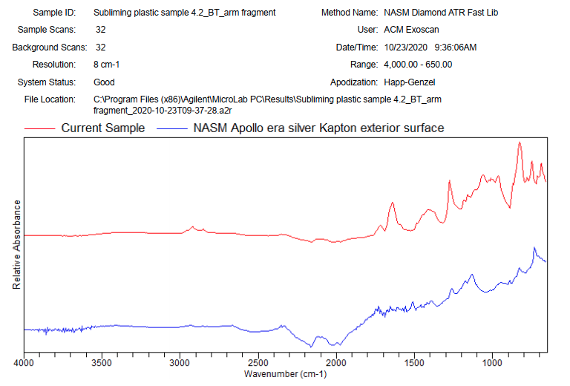
Fig. 3. FITR Spectra for Sample 4: before application of AESUB Scanning Spray
Spectra showing library match for NASM Apollo era silver Kapton exterior surface

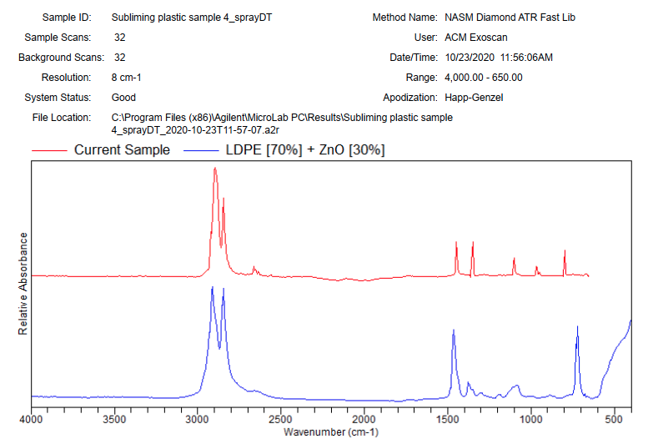
Fig. 4. FITR Spectra for Sample 4: with application of AESUB Scanning Spray
Spectra showing library match for 70% Low density polyurethane and 30% ZnO

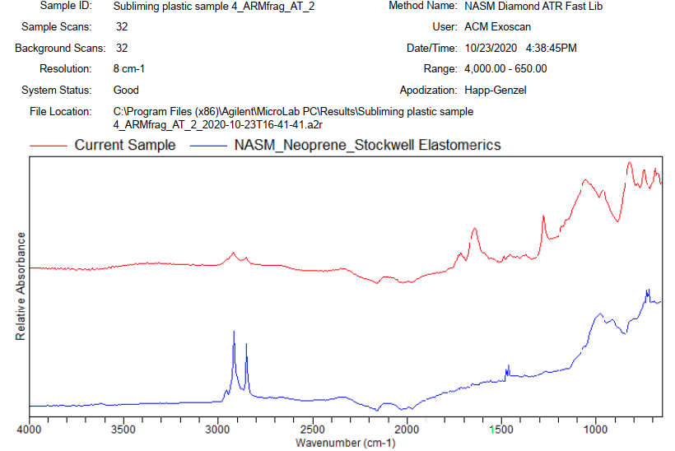
Fig. 5, FITR Spectra for Sample 4, Trail 1: after four hours of sublimation
Spectra showing library match for NASM Neoprene Stockwell elastomers

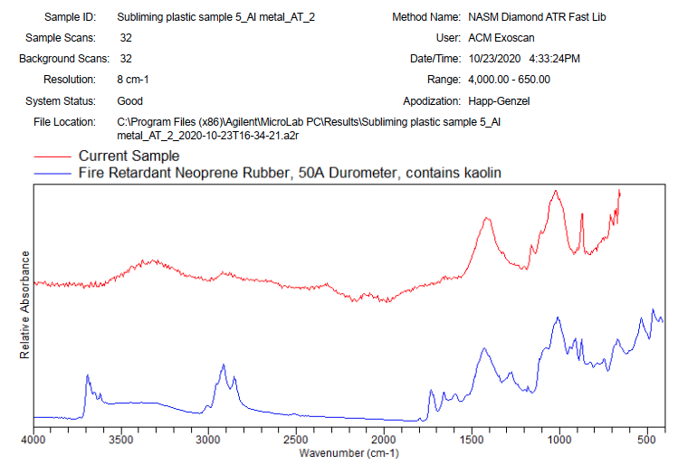
Fig. 6. FITR Spectra for Sample 4, Trail 2: after four hours of sublimation
Spectra showing library match for NASM Neoprene Stockwell elastomers
HIROX MICROSCOPE IMAGES

Table 2: Hirox Images of Samples
Sample | Before Spray Application (BT) | Spray Applied (DT) | After Sublimation (AT)
1 – PVC/PVA time scale | 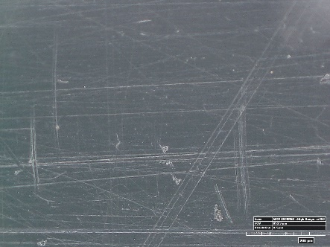 | 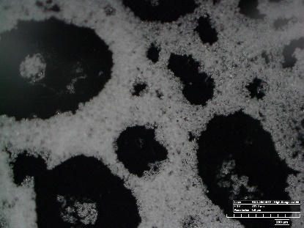 | 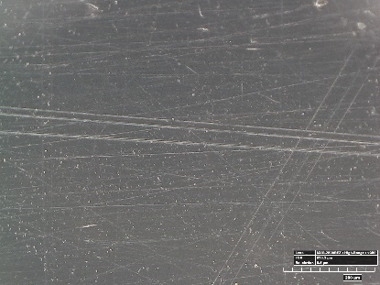
2 – PVC/PVA index chart | 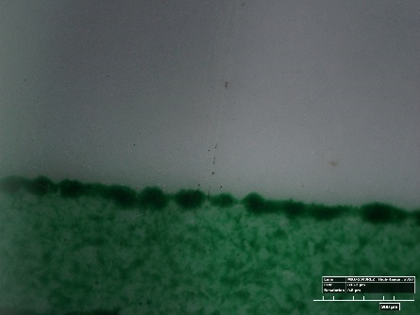 | 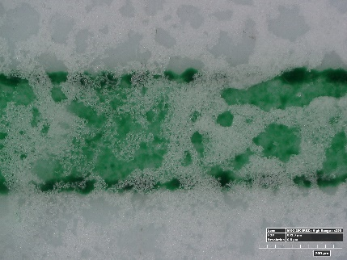 | 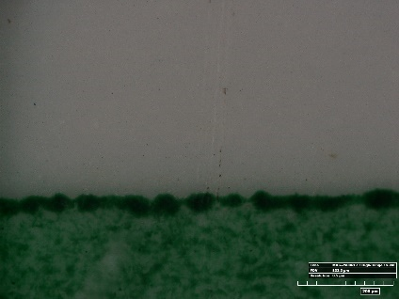
3 – glass slide | 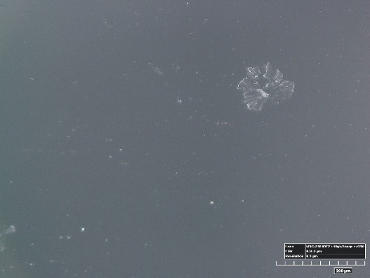 | 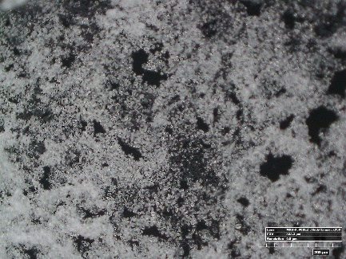 | 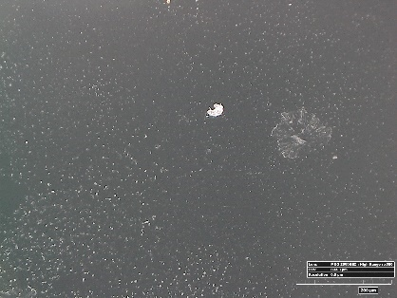
4 – Aircraft recognition  Model (ARM) Fragment | 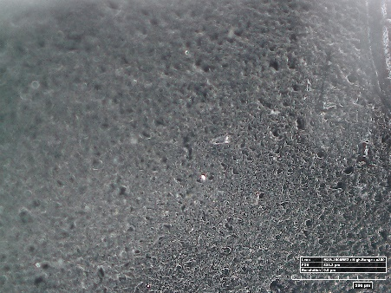 | 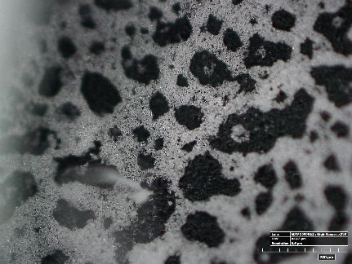 | 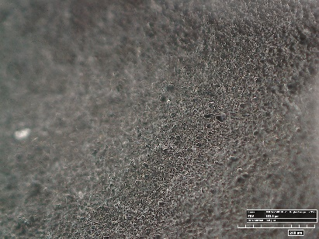
5 – Aluminum tray | 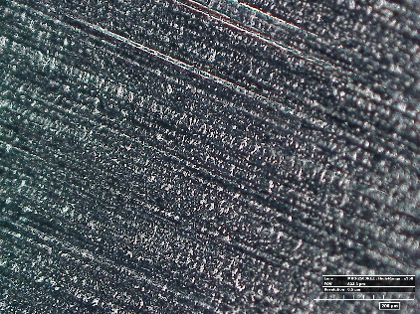 | 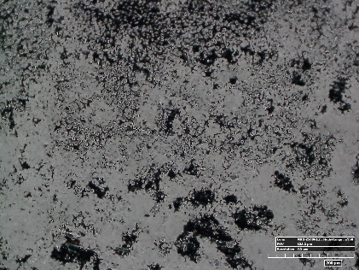 | 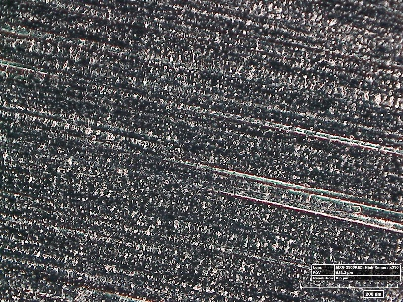

Identified via FTIR unless otherwise noted. Specific results are given in Table 2.
Identified by Dr. Molly McGath and Dr Odile Madden in 2012. DEP: diethyl phthalate, TPP: Triphenyl phthalate.
Agilent 4100 ExoScan FTIR using the 4100 ExoScan FTIR Spherical Diamond ATR sampling technique.
Hirox KH-8700 Digital Microscope
AESUB Blue specifies four hours at 21ºC/69.8ºF as the minimum amount of time required for the material to fully sublimate. The lab was at 71ºF during this experiment.

